**WORKSHEET 7**

**Student Name:** Vivek Kumar **UID:** 21BCS8129

**DOMAIN CAMP:** 16-01-2023 to 28-01-2023 **Section/Group:** DWWC-77

**Subject Name:** IT Skills (DSA)

# Question 1. KEYS AND ROOMS

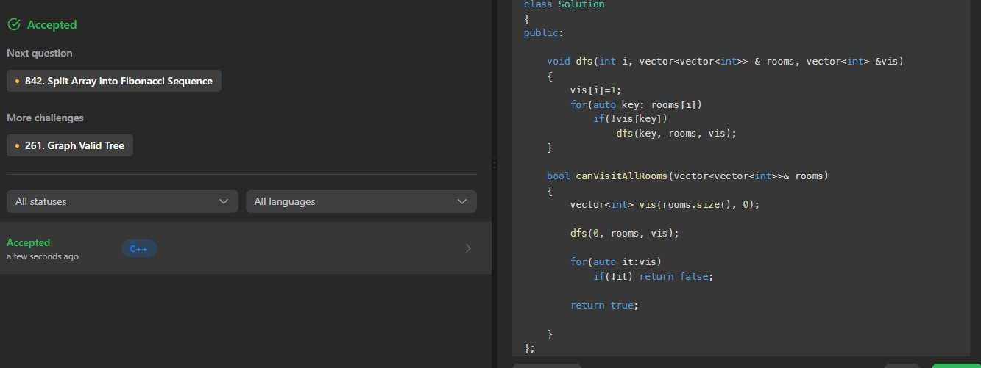

# Question 2. HIDDEN COLORED GRAPH

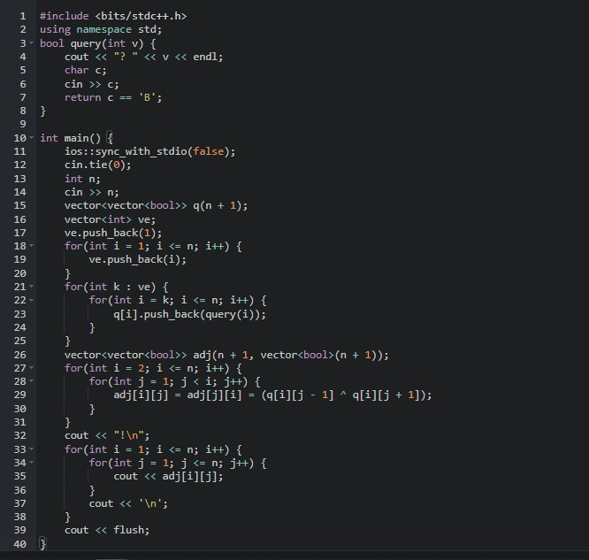

**SOLUTION:**

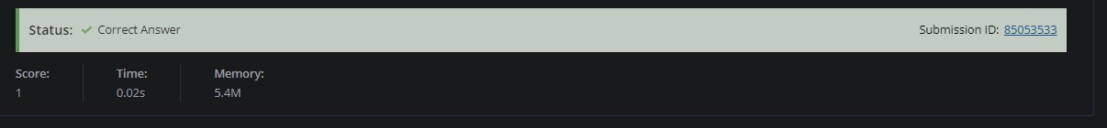

# Question 3. WINTER

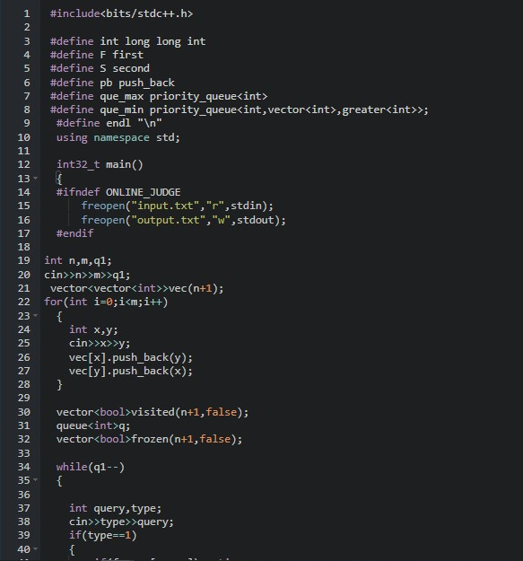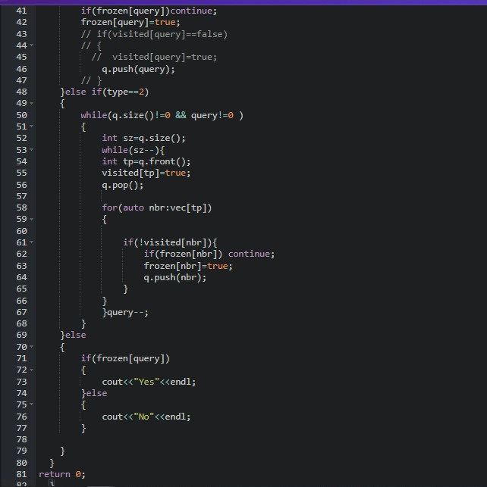

**SOLUTION:**

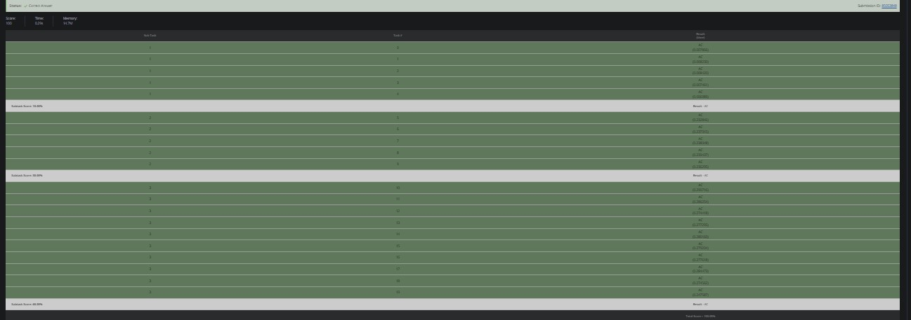

# MINIMAL TRAVEL TIME

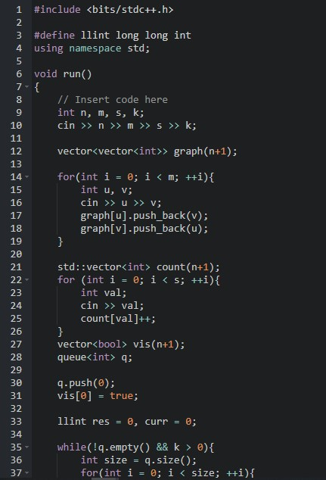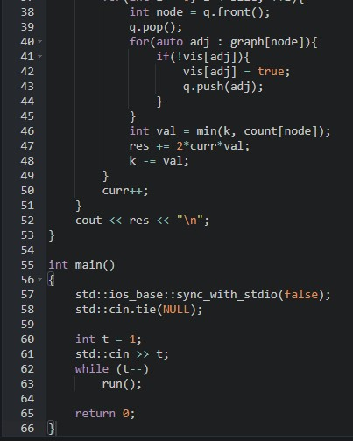

**SOLUTION:**

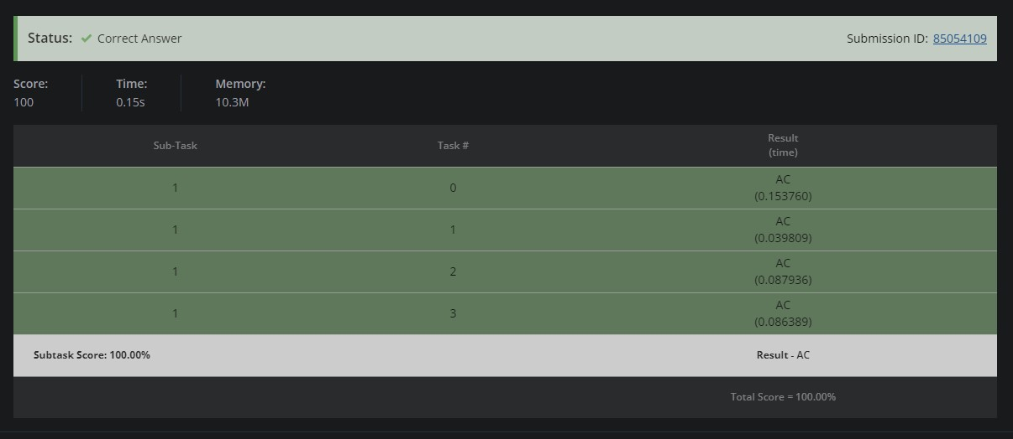

# CHEF AND REVERSING

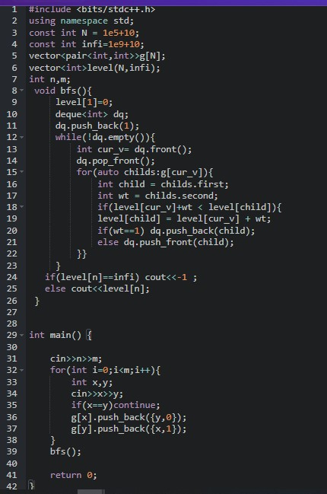

**SOLUTION:**

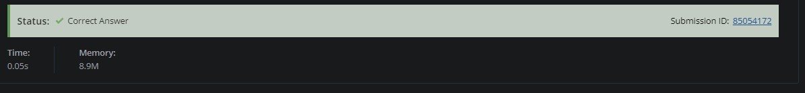

# CHEF AND EDGE FLIPPING

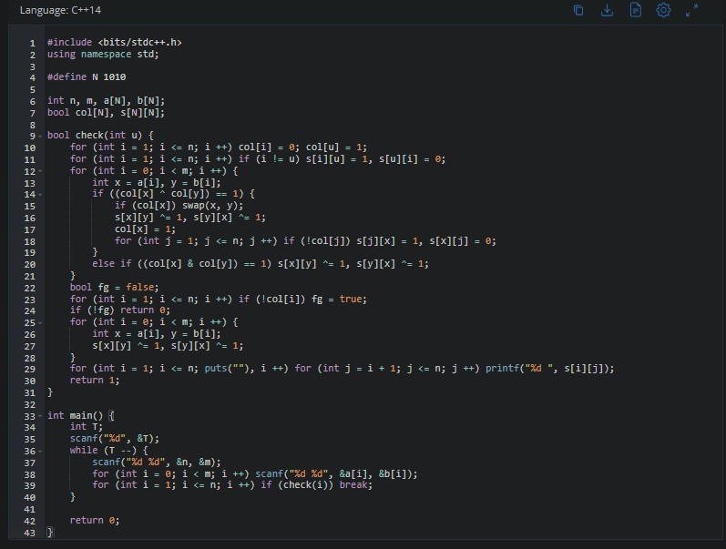

**SOLUTION:**

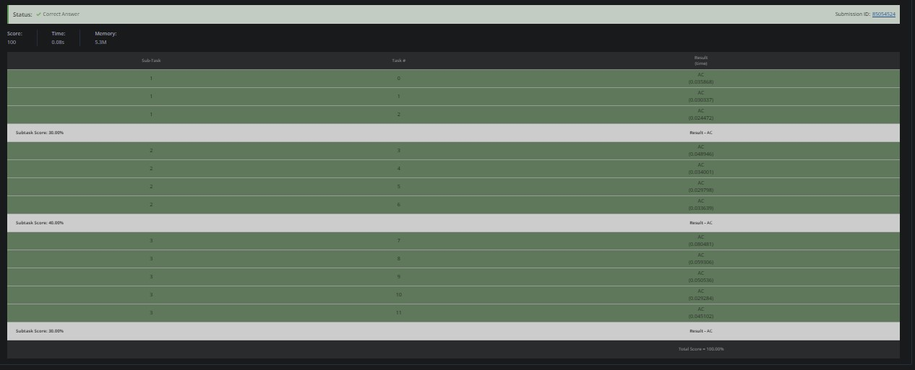

# MANGO MARKET

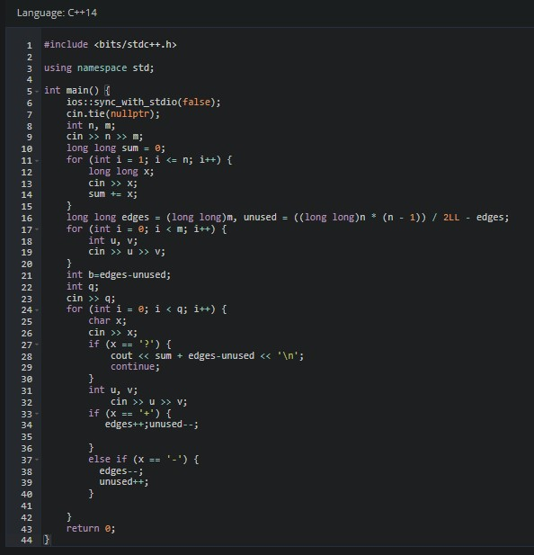

**SOLUTION:**

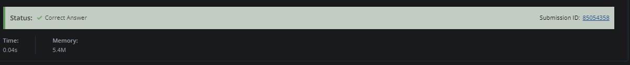

# Question 8. ONE MORE WEIRD GAME

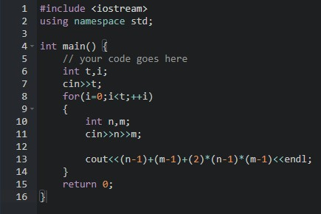

**SOLUTION:**

